### **🔹 Conceptual Questions**

1. **What is Data Visualization and why is it important?**

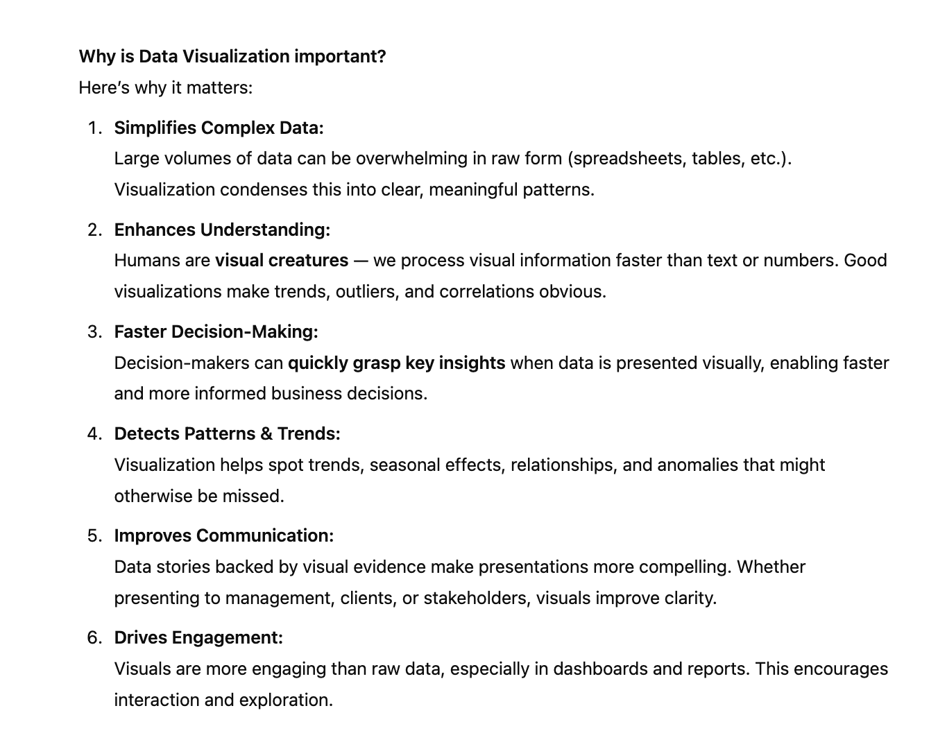

1. **How do you decide which type of chart to use for a given dataset?**

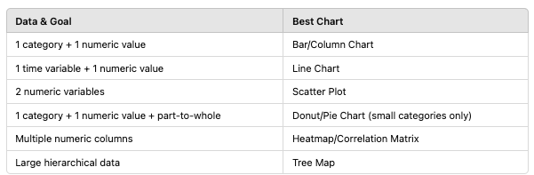

1. **What are some common mistakes to avoid when creating visualizations?**

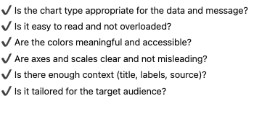

1. **Explain the difference between exploratory and explanatory visualizations.**

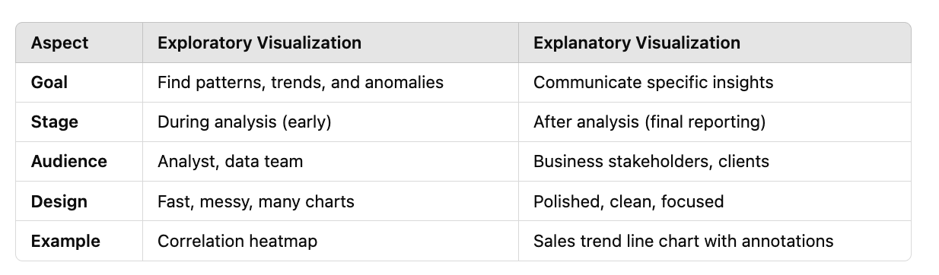

1. **What is the importance of color selection in visualizations?**

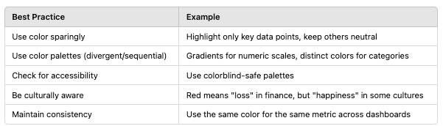

1. **What is the difference between a heatmap and a choropleth map?**
2. **When would you use a bar chart over a line chart?**

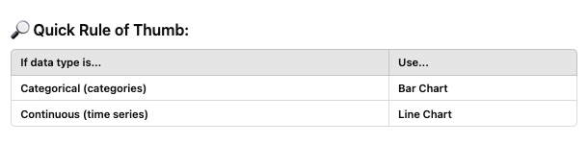

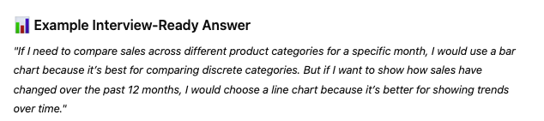

1. **What is data-ink ratio? How does it improve a chart?**

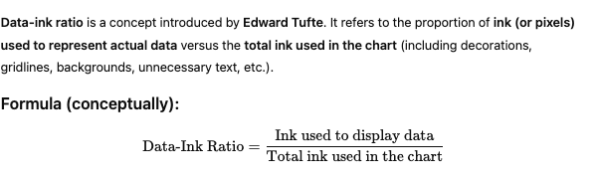

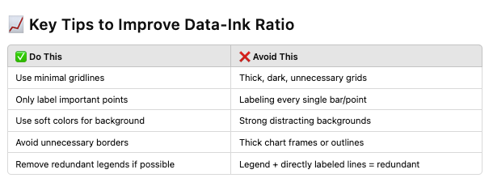

1. **Explain the concept of 'storytelling with data'. How do you apply it in real projects?**

### **🔹 Technical Questions (Tool-Specific or Coding)**

1. **What libraries have you used for Data Visualization in Python? Compare Matplotlib, Seaborn, and Plotly.**

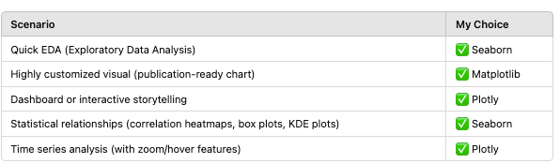

1. **How would you visualize the distribution of a continuous variable?**

I. For a detailed view of the distribution's shape, use histograms or density plots.  
II. For comparing distributions across groups and identifying outliers, use box plots or violin plots.

1. **Write code to plot a box plot in Python for a given dataset.**plt.boxplot(data=df)
2. **How would you visualize correlations between multiple numeric variables?**
3. **In Tableau/Power BI, how do you create a dual-axis chart?**
4. **What are tooltips and how would you customize them in Tableau/Power BI?**
5. **In Matplotlib, how do you adjust figure size and font size?**
6. **How would you plot time series data with seasonality?**

### **🔹 Scenario-Based Questions**

1. **You have sales data for the past 5 years across 4 regions. How would you visualize trends and patterns?**
2. **If your audience is senior management with limited time, what type of visualizations would you use to present revenue performance?**
3. **You found that your chart is misleading. What actions would you take to fix it?**

### **🔹 Advanced / Case Study Style**

1. **You need to design a dashboard for monitoring server performance. What key metrics and visualizations would you include?**
2. **How do you handle missing data in visualizations?**
3. **How would you visualize both categorical and numerical variables together?**
4. **What is a small multiple chart? When would you use it?**
5. **Explain how you would use annotations in a chart to improve understanding.**

### **🔹 Statistical Visualization**

1. **What visualizations are best for comparing two groups statistically?**
2. **Explain how you would visualize confidence intervals.**
3. **How do you plot a regression line along with data points?**
4. **What’s the difference between a histogram and a bar chart?**
5. **How would you represent outliers in a dataset?**